Name:
My Plastic Diary
Over the next week keep a tally chart of how many single use plastic items you use.

 | Monday | Tuesday | Wednesday | Thursday | Friday | Saturday | Sunday | Total for the week
Plastic bottles

Plastic cups

Plastic bags

Plastic straws
Plastic food containers eg. yoghurt pots

List here any other single use plastic items that you have used:
My Plastic Diary

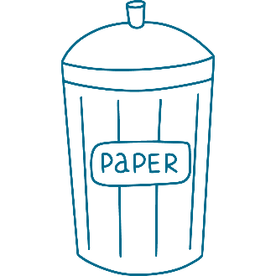
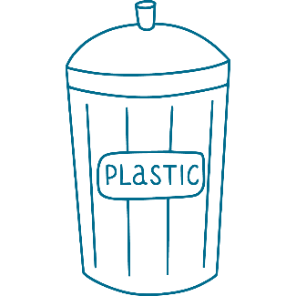
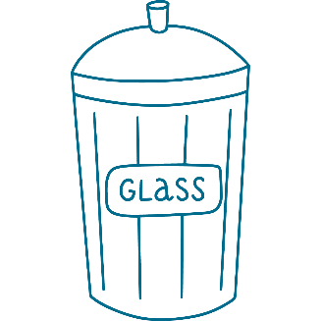
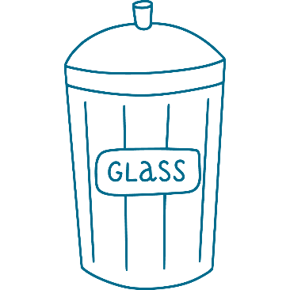
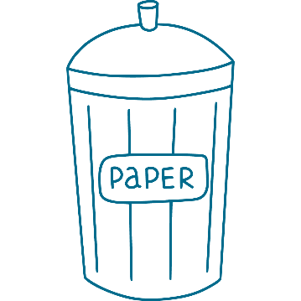
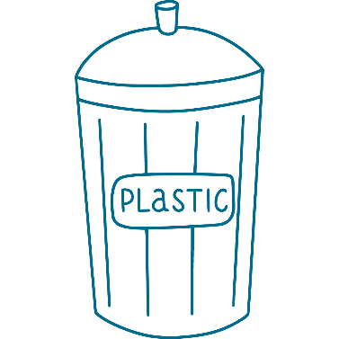
What alternatives to single use plastics have you used or could you use in the future?
www.ascentis.co.uk

